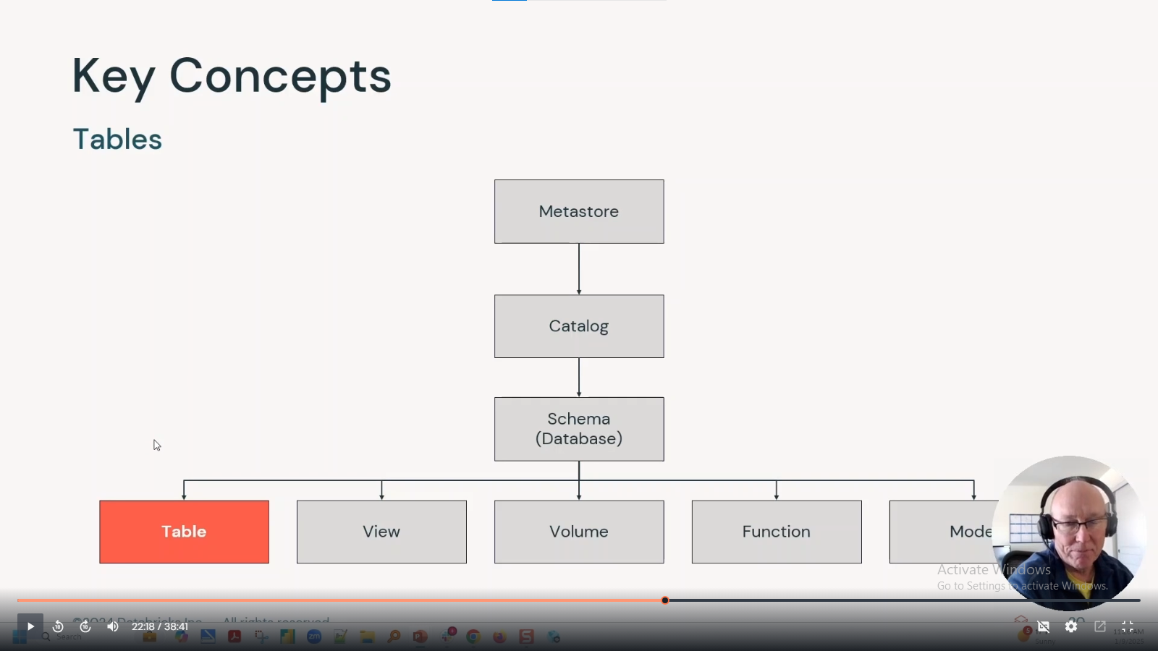

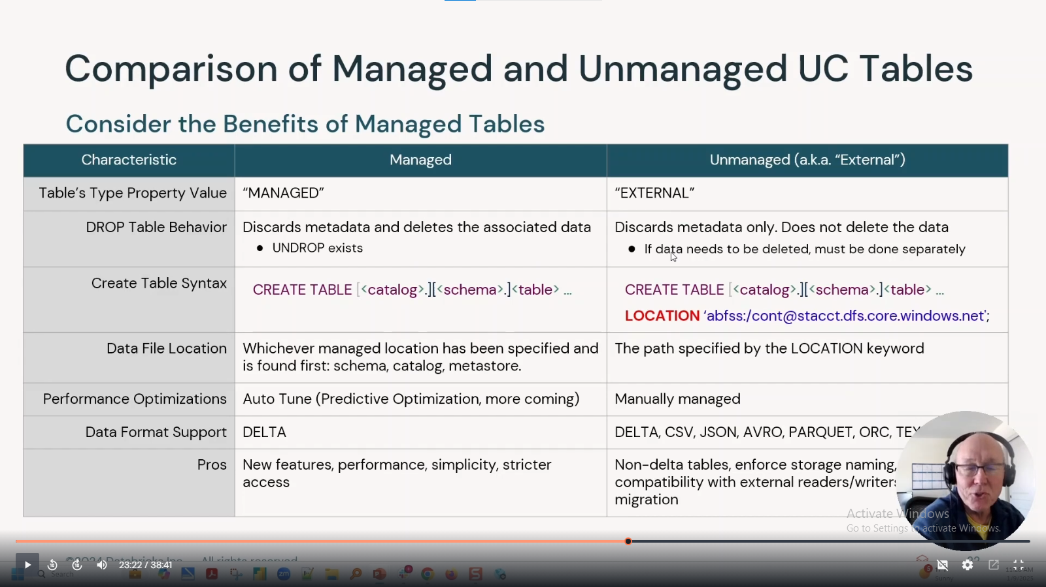

Function creation-

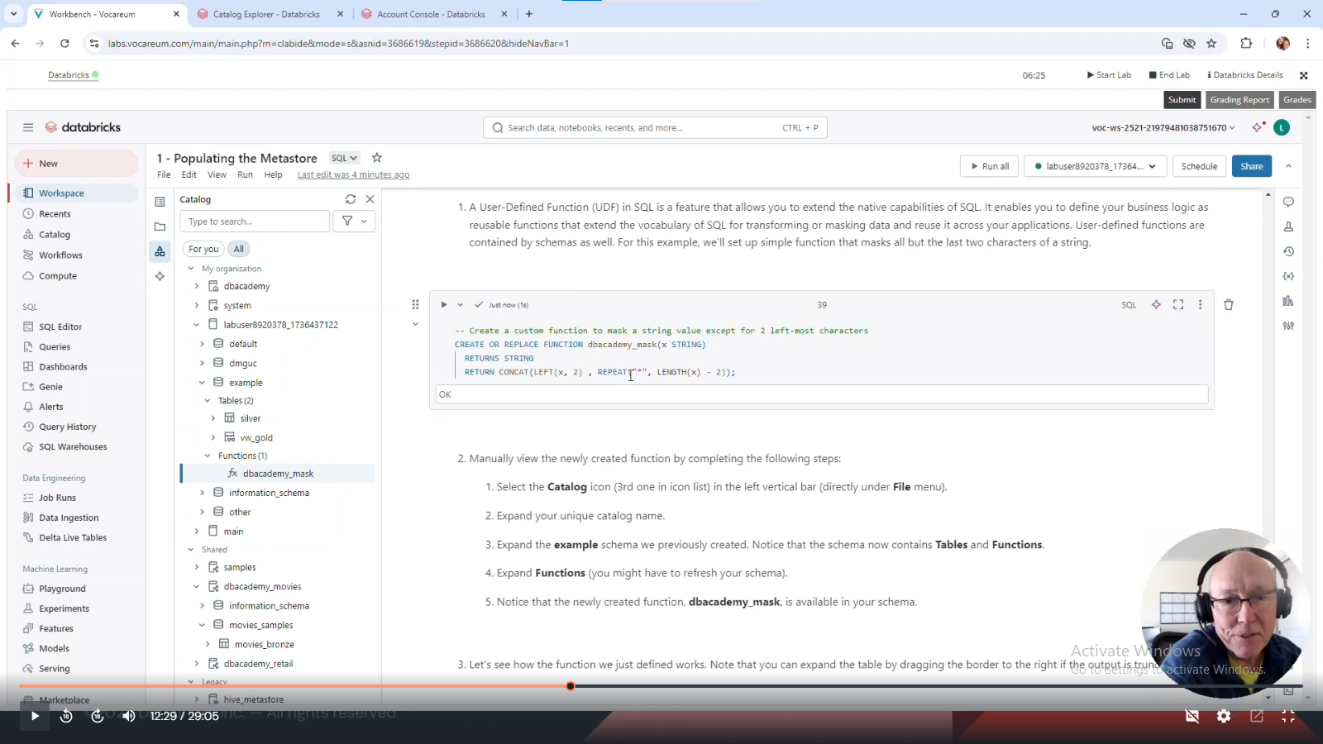

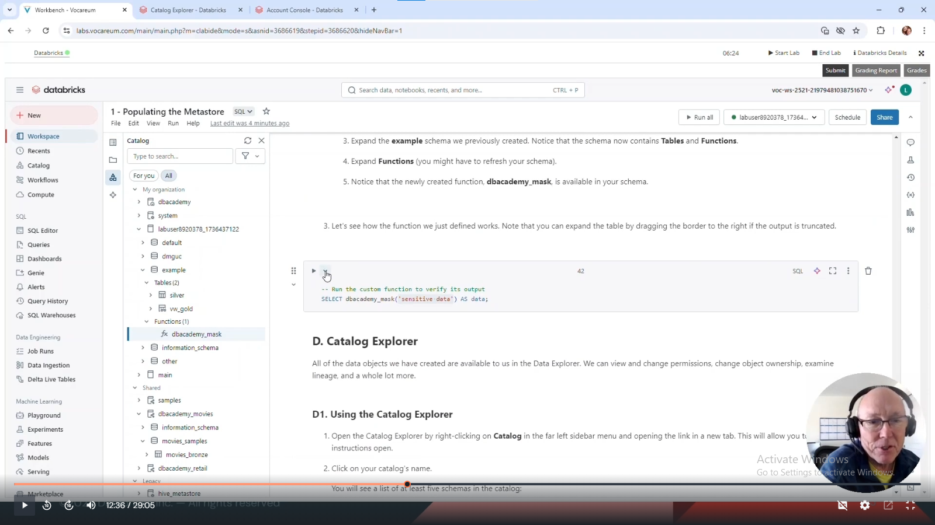

Catalog permissions-

Go to catalog explorer, table, permissions and grant them -

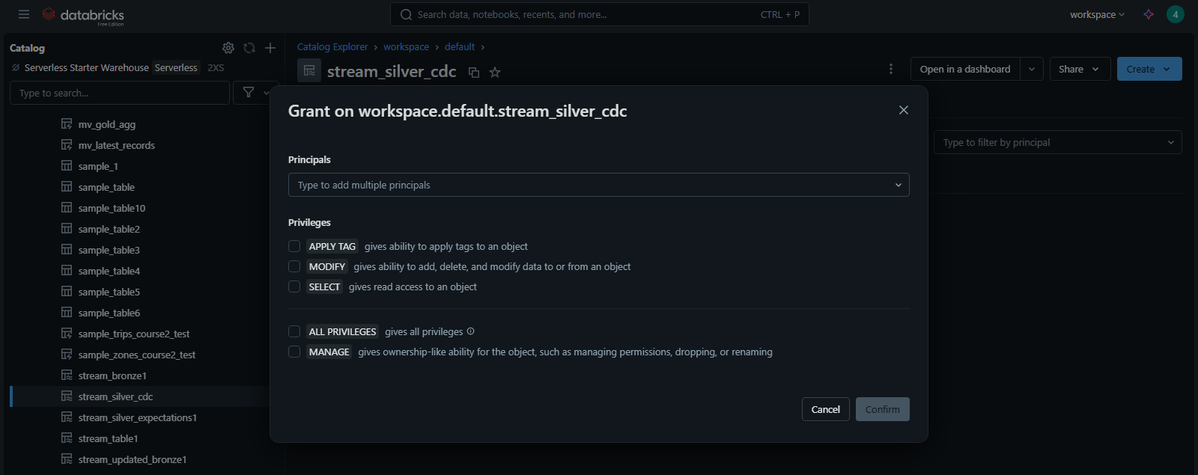

+ history of operations on table, lineage showing dependencies, catalog explorer is like katalogam we use in jio

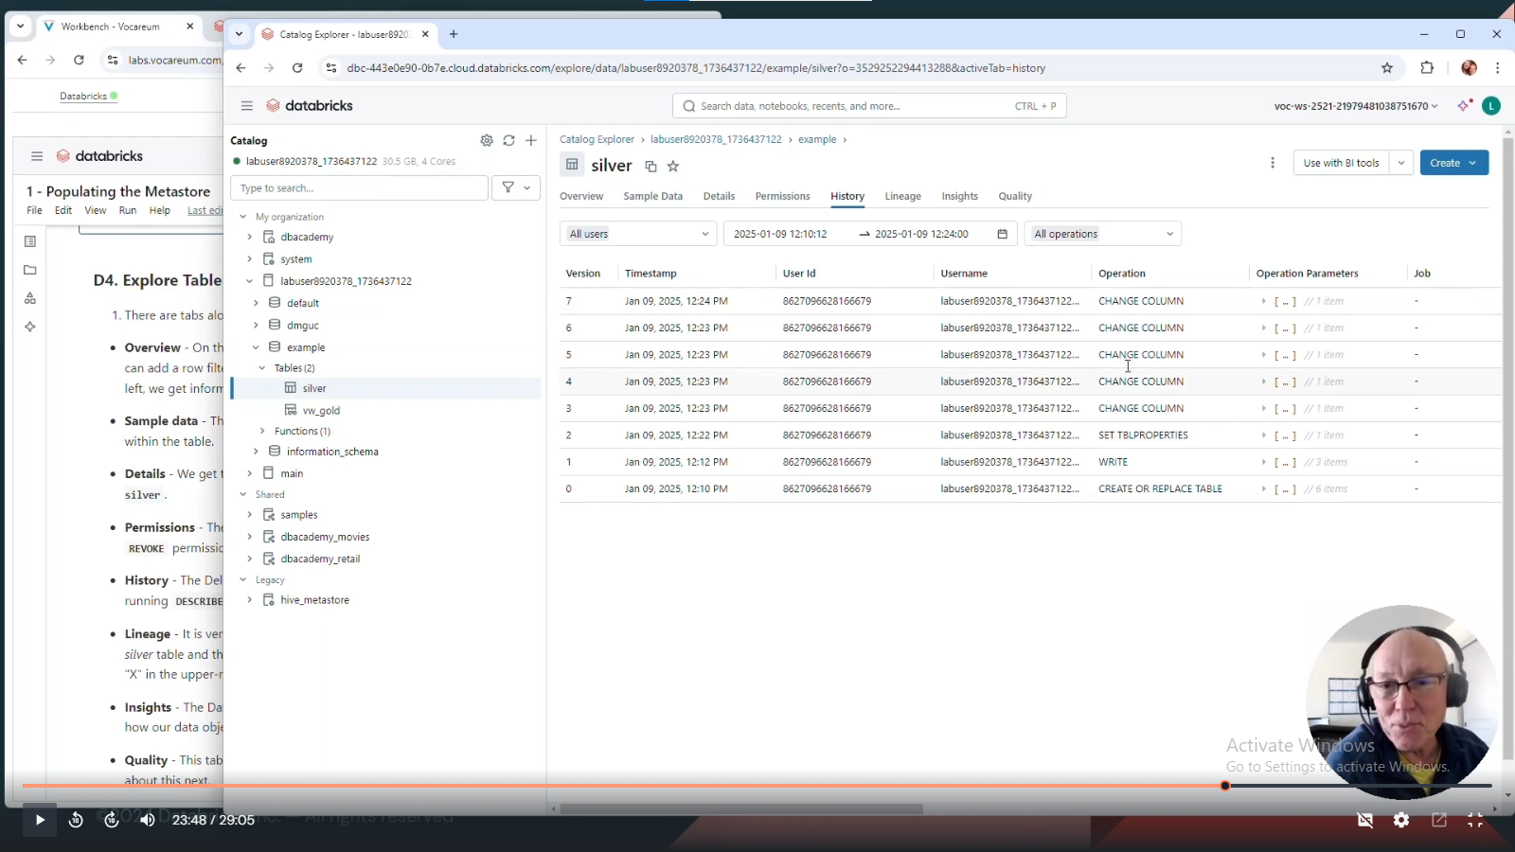

Drop table table_name

Select * from table_name

Undrop table table_name

(it works, select * from table_name)

7 days it works

### Organisation and access patterns

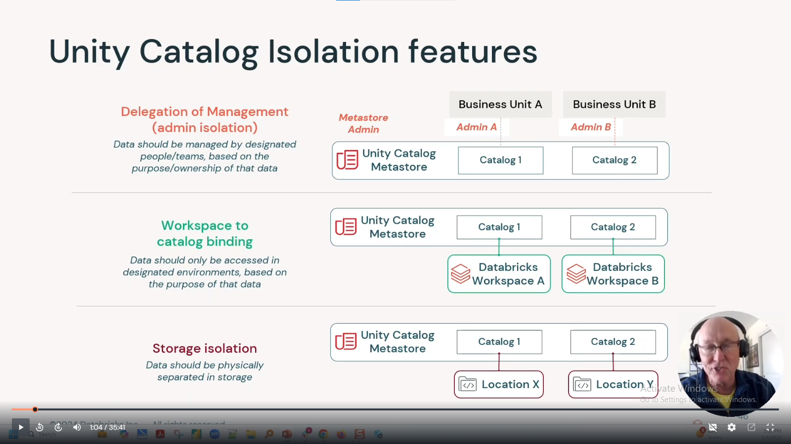

Drop catalog catalog_name;

(error if catalog is not empty)

So use drop catalog catalog_name cascade;

Can grant/revoke permission to view catalogs in different workspaces under same metastore-

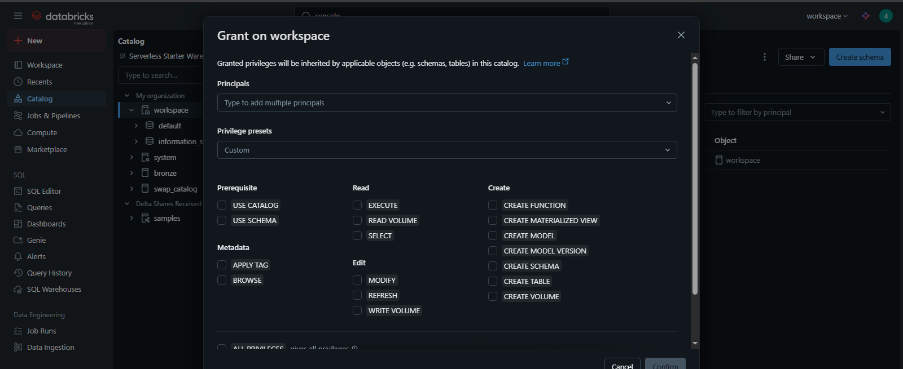

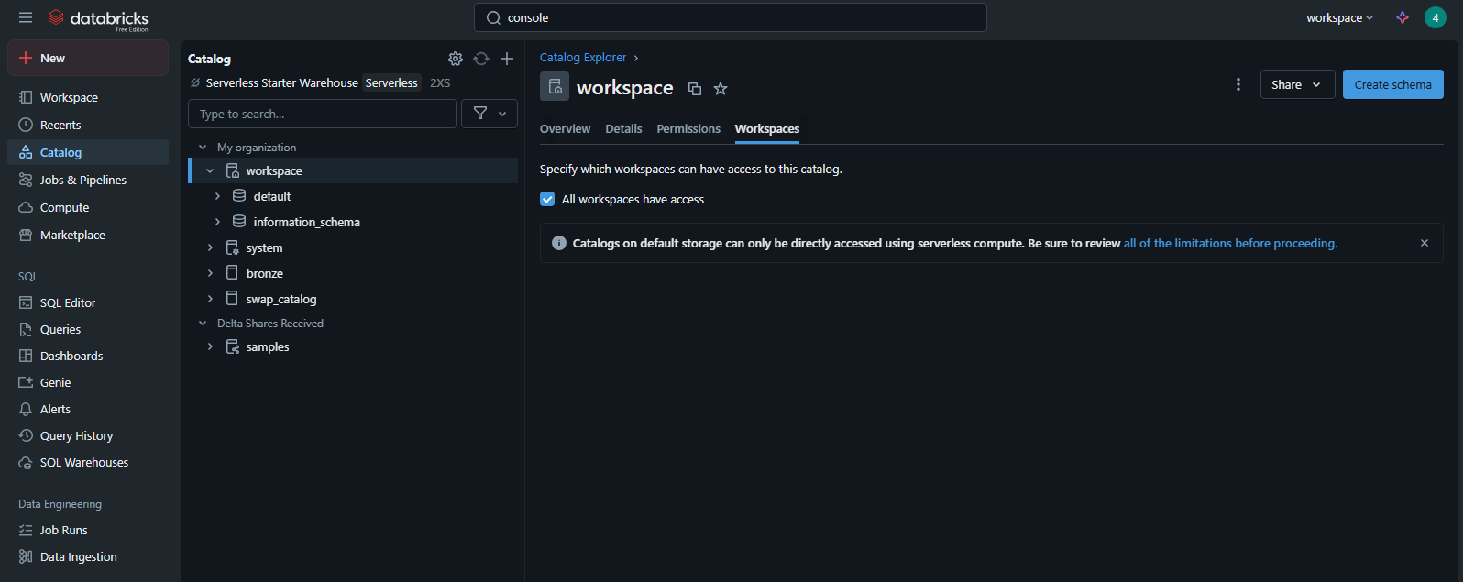

### Upgrade tables to unity catalog

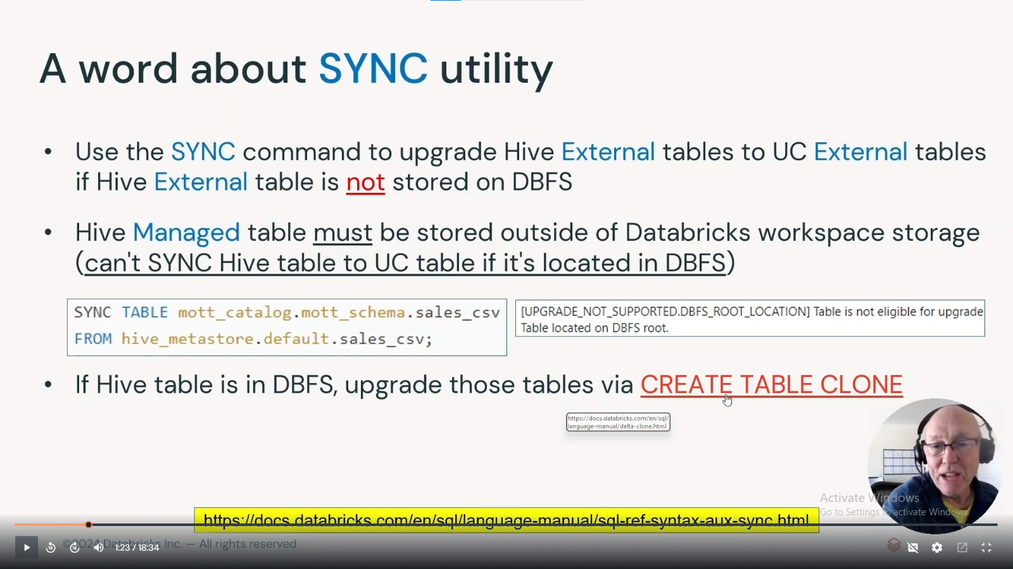

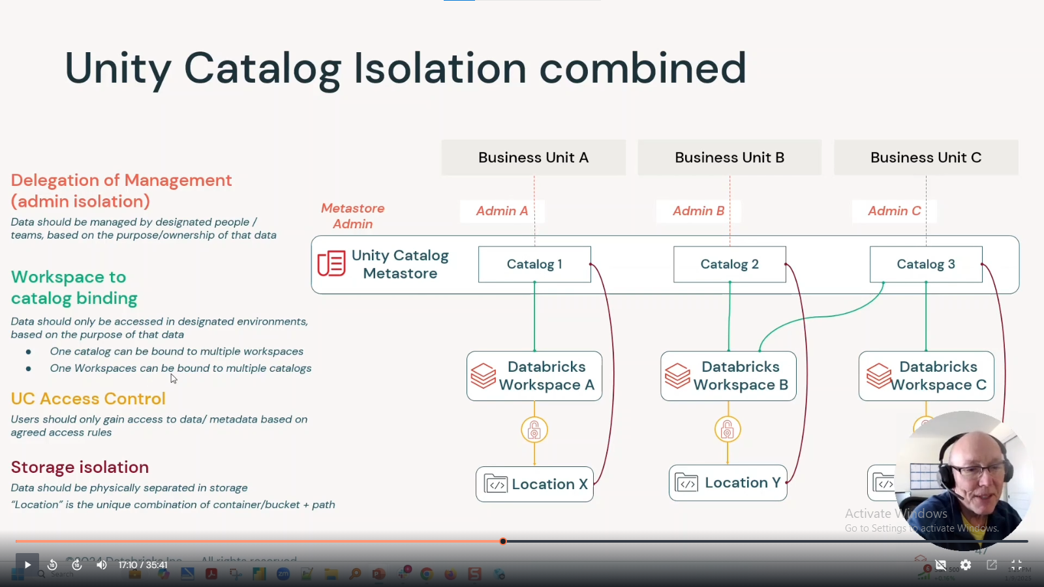

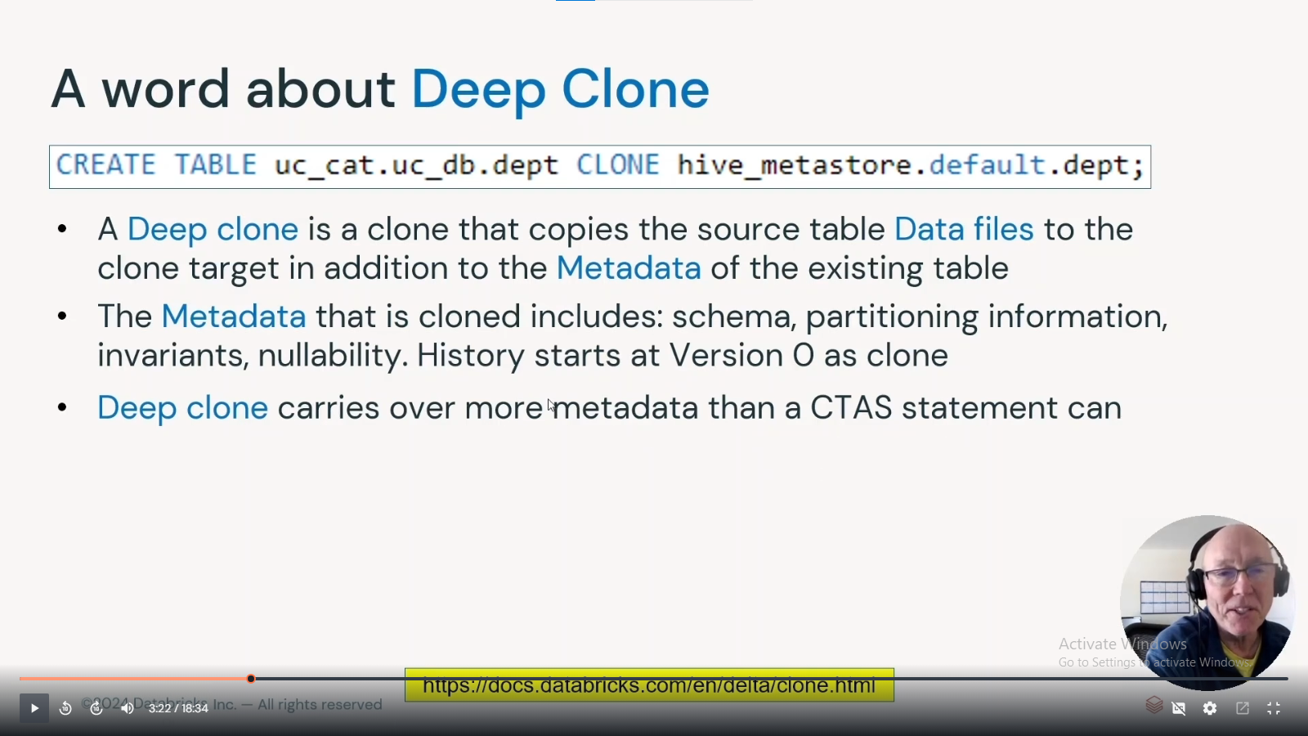

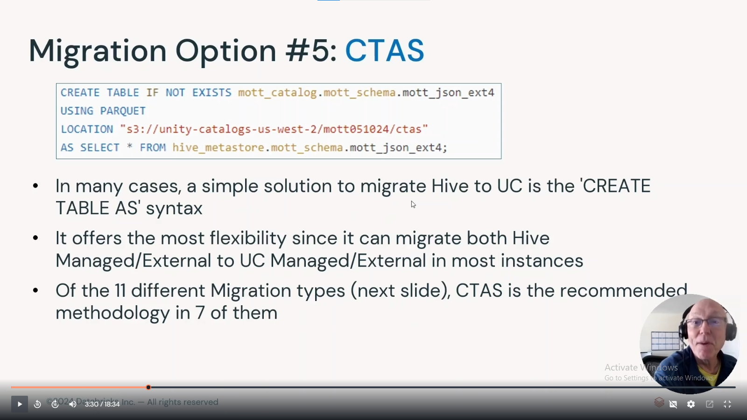

Cmd-

Sync, deep clone, ctas (migrate hive tables to unity catalog)

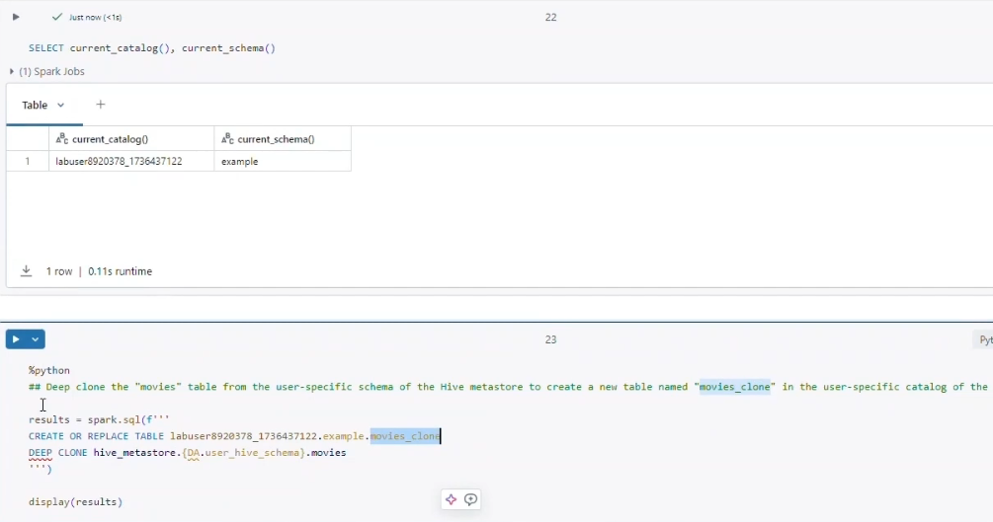

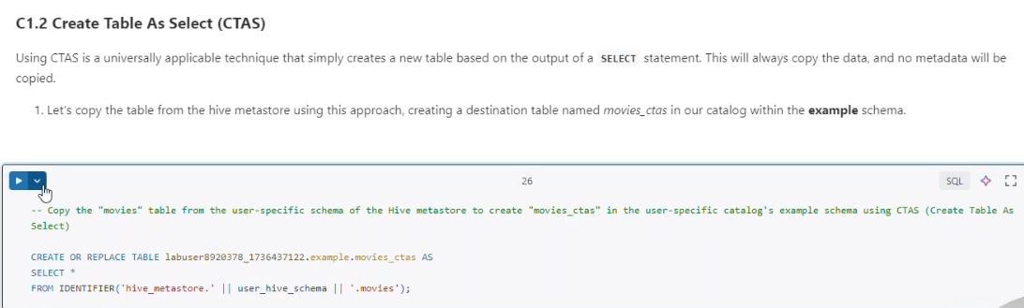

Apply transformations during migration-

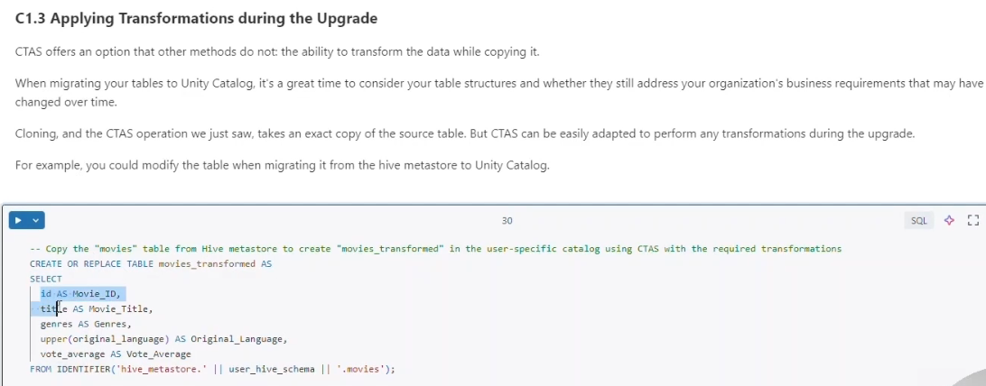

Use unity catalog directly-

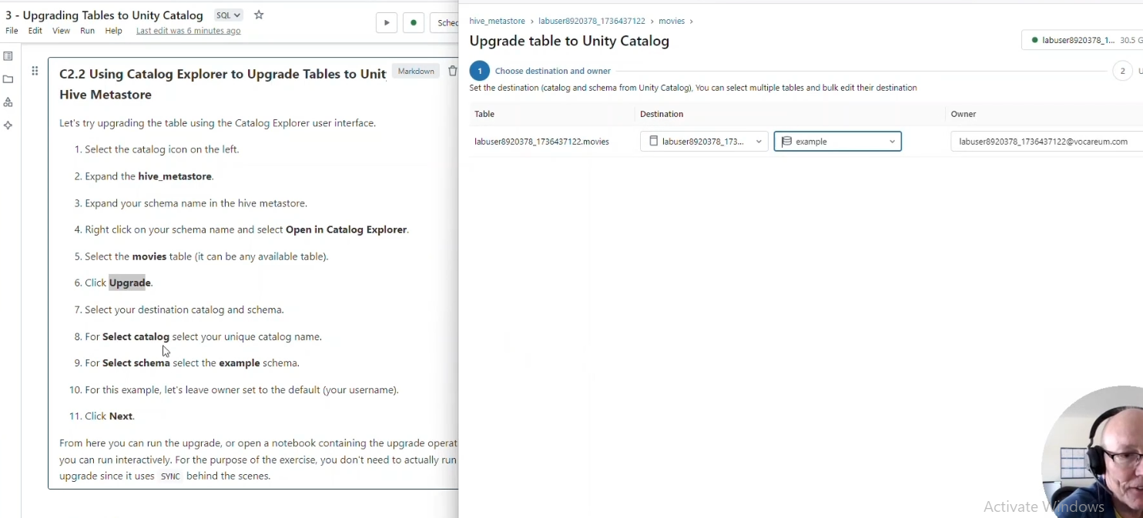

### query lifecycle

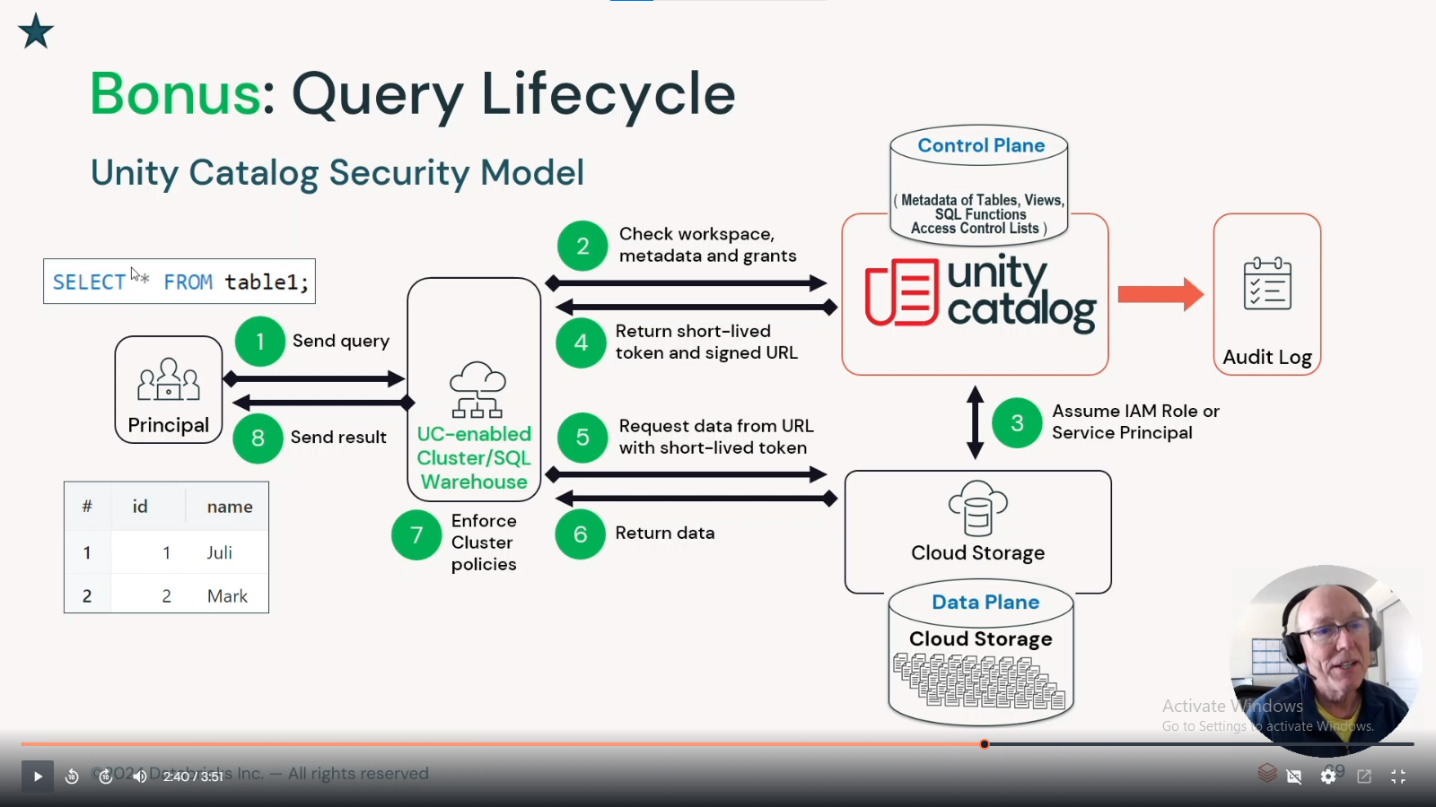

Access hive tables-

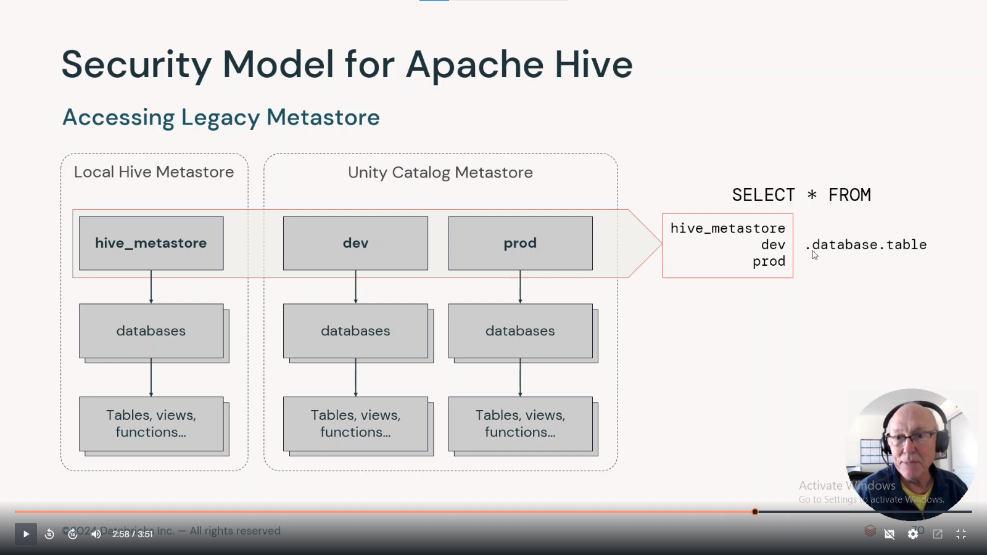

## market place- meh, just kinda google